ACADEMIC INTERNSHIP REPORT

Internship carried out from the **1st, July 2025** to the **30th, September 2025**

In view of obtaining a **Higher Technician Diploma (HTD)** in software Engineering

**Academic Supervisor**

Mr. NDIFOR Roger

Lecturer At AICS

**Professional Supervisor**

Mr. EPOUPA Pelayah

Software Developer

Written By

**KOM DZUFING Laurentine**

LEVEL 2 Student

REPUBLIQUE DU CAMEROUN

PAIX – TRAVAIL – PATRIE



One Love, One Mind, One Legacy!

Tel: 678 358 509 / 692 199 722

LinkedIn: shaderl

WebSite: www.shaderl.com

Email: info@shaderl.com

REPUBLIC OF CAMEROON

PEACE-WORK-FATHERLAND



AFRICAN INSTITUTE OF COMPUTER SCIENCES

P.O. Box: 13719 Yaoundé, Cameroun

Tel : 242 72 99 58 / 242 72 99 57

Website: www.iaicameroun.com

Under The Supervision Of ;

ACADEMIC YEAR 2024-2025

THEME: DEVELOPMENT OF AN EDUCATIONAL 3D VISUALIZATION TOOL FOR GEOMETRICAL ANALYSIS

# DEDICATION

THIS WORK IS DEDICATED TO MY LATE FATHER,

MR DZUFING FERDINAND.

# ACKNOWLEDGEMENTS

# TABLE OF CONTEXT

DEDICATION i

ACKNOWLEDGEMENTS ii

TABLE OF CONTEXT iii

LIST OF ABBREVIATIONS iv

ABSTRACT v

RÉSUMÉ vi

GENERAL INTRODUCTION 1

[PART ONE : INSERTION PHASE 2](https://d.docs.live.net/cc48cb7f90375ea0/Documentos/Laura's_Report8%20(AutoRecovered).docx#_Toc204599438)

[PART 2: TECHNICAL PHASE 13](https://d.docs.live.net/cc48cb7f90375ea0/Documentos/Laura's_Report8%20(AutoRecovered).docx#_Toc204599439)

[FILE 1: STUDY OF THE EXISTING SYSTEM 15](https://d.docs.live.net/cc48cb7f90375ea0/Documentos/Laura's_Report8%20(AutoRecovered).docx#_Toc204599440)

[FILE 2: THE SPECIFICATION BOOK 20](https://d.docs.live.net/cc48cb7f90375ea0/Documentos/Laura's_Report8%20(AutoRecovered).docx#_Toc204599441)

[FILE 3: THE ANALYSIS FILE 28](https://d.docs.live.net/cc48cb7f90375ea0/Documentos/Laura's_Report8%20(AutoRecovered).docx#_Toc204599442)

[FILE 4: THE CONCEPTION FILE 37](https://d.docs.live.net/cc48cb7f90375ea0/Documentos/Laura's_Report8%20(AutoRecovered).docx#_Toc204599443)

[File 5: THE REALISATION FILE 51](https://d.docs.live.net/cc48cb7f90375ea0/Documentos/Laura's_Report8%20(AutoRecovered).docx#_Toc204599444)

[FILE 6: FUNCTIONALITY TEST 60](https://d.docs.live.net/cc48cb7f90375ea0/Documentos/Laura's_Report8%20(AutoRecovered).docx#_Toc204599445)

[FILE 7: INSTALLATION AND USER GUIDE 66](https://d.docs.live.net/cc48cb7f90375ea0/Documentos/Laura's_Report8%20(AutoRecovered).docx#_Toc204599446)

GENERAL CONCLUSION 72

BIBLIOGRAPHY vii

WEBOGRAPHY viii

ANNEXES ix

TABLE OF CONTENTS x

# LIST OF ABBREVIATIONS

# ABSTRACT

Many students, both globally and in developing countries like Cameroon, face significant challenges in understanding mathematical concepts. These difficulties are often rooted in the nature of mathematics, which makes it hard for learners to visualize and internalize key ideas. This project addresses these challenges by developing an interactive 3D visualization application tailored to assist students, particularly at the secondary and high school, in exploring and understanding geometric concepts. The application focuses on visualizing vector spaces, plane figures, transformations, and their properties, allowing students to interact with mathematical theorems and equations dynamically. By bridging the gap between theory and tangible visualization, the tool aims to make learning mathematics more accessible, engaging, and impactful for students.

### Keywords:

* Students
* Challenges
* Understanding
* 3D visualization
* Geometric concepts
* Secondary and high school

# RÉSUMÉ

De nombreux élèves, à travers le monde et dans les pays en développement comme le Cameroun, rencontrent des défis significatifs pour comprendre les concepts mathématiques. Ces difficultés trouvent souvent leur origine dans la nature abstraite des mathématiques, ce qui rend difficile pour les apprenants de visualiser et d’intégrer pleinement les idées essentielles. Ce projet vise à relever ces défis en développant une application interactive de visualisation 3D conçue pour aider les élèves, en particulier ceux du secondaire et du lycée, à explorer et à comprendre les concepts géométriques. L’application se concentre sur la visualisation des espaces vectoriels, des figures planes, des transformations et de leurs propriétés, permettant aux élèves d’interagir de manière dynamique avec les théorèmes et les équations mathématiques. En comblant le fossé entre la théorie abstraite et la visualisation tangible, cet outil vise à rendre l’apprentissage des mathématiques plus accessible, engageant et impactant pour les élèves.

### Mots-clés :

Étudiants

Défisj

Compréhension

Visualisation 3D

Concepts géométriques

Collège et lycée

# GENERAL INTRODUCTION

Mathematics, as a universal language, serves as the foundation of countless disciplines, from science and engineering to technology and economics. However, many students around the world— and particularly in developing countries like Cameroon—struggle with grasping its often-challenging concepts. The barriers to understanding mathematics are multifaceted, stemming from insufficient resources, lack of interactive teaching tools, and the ideational nature of mathematical theories. These challenges are particularly evident in subjects like geometric analysis, vector spaces, and transformations, where visual representation is key to comprehension.

This project arises from the critical need to address these issues by bridging the gap between theoretical mathematics and tangible learning experiences. The focus is on the creation of an interactive 3D visualization application aimed at assisting secondary and high school students in Cameroon to better understand core mathematical concepts. By utilizing modern technology, the application will allow users to not only visualize geometric figures and vector spaces in three dimensions but also interact dynamically with mathematical equations and their properties. Through this innovation, students will be empowered to explore, experiment, and develop a more intuitive understanding of the principles underlying geometric analysis and transformations.

The report documenting this initiative is divided into two phases and seven structured files, each addressing a key milestone in the project’s development journey:

1. Insertion phase
2. Technical phase:

* Study of the existing system,
* Specification book,
* The analysis file,
* The conception file,
* The deployment file,
* The functionality test file,
* Installation and user guide

.

# PART ONE : INSERTION PHASE

## Preamble

This section of the report will cover details of how we were welcomed in the host company, presentation, organization and brief introduction to our project.

Content

INTRODUCTION

1. WELCOME AND INSERTION
2. GENERAL PRESENTATION OF THE COMPANY
3. ORGANIZATION OF THE COMPANY
4. GEOGRAPHICAL LOCATION
5. BRIEF PRESENTATION OF PROJECT THEME

CONCLUSION

## INTRODUCTION

The insertion phase in a company is a period during which we discover our working  
environment, the staff of the company and other interns. Here, we will begin by discussing our first two weeks in the company, how we were welcomed and how we began adapting to our internship environment, we will proceed by exploring the history of the company, discovering its missions, learning what its major activities are, and witnessing some of its key realizations. We will also get to understand how the company is structured administratively and functionally so that it operates effectively and accomplishes its goals. Furthermore, we will look at the hardware equipment used by the company, and the software resources used in its daily operations. We will then introduce our chosen theme for the internship period, briefly elaborate on It.

## WELCOME AND INSERTION

We arrived at SHADERL on Tuesday 01st July 2025, at 08:00 a.m. we were received by the shaderl team who introduced us to our workspace, gave us an official welcome to the enterprise, its activities and its different rules and regulations. Also, we discussed on the enterprise’s preferred languages and frameworks, our professional supervisor encouraged us through his past working experiences in different enterprises.

The first two week we started with our internship report by configuring our MS WORD processor, reviewing key concepts like page numbering, styles, section breaks, page breaks etc. There was a talk on project ideas, we were advised to propose project ideas and we were assigned the tasks to carry out research on these ideas. The objective was that the enterprise did not want to impose some themes on us. For those who could not find a theme, the enterprise could propose an idea for them to think about.

## GENERAL REPRESENTATION OF SHADERL

### BACKGROUND

Shaderl is a dynamic, non-governmental tech startup founded in 2023 by **Asane Derick** with a bold vision: to bridge the gap between traditional industries and the rapidly evolving digital economy. Recognizing the urgent need for digital transformation, Shaderl is committed to providing **cutting-edge IT solutions** while empowering the next generation of innovators.

### MISSION

At Shaderl, we harness the power of **AI and cutting-edge technology** to democratize digital transformation. Our mission is to **empower individuals and businesses** with intelligent tools, accessible education, and personalized mentorship bridging the gap between today’s potential and tomorrow’s opportunities. We believe AI should **augment human potential, not replace it**. By making AI-driven solutions practical and ethical, we equip the next generation to lead, innovate, and thrive in an era where **human creativity meets machine intelligence**.

### VISION

At Shaderl, we envision a world where **technology unites humanity**, where innovation is driven by collective purpose, not just profit. By putting **“People First”**, we strive to build a future where:

* **One** **Love**→ Technology fosters inclusion, empathy, and global collaboration, breaking down barriers.
* **One Mind**→ AI and digital tools **amplify human potential**, creating shared knowledge and opportunity.
* **One Legacy**→ Every individual we empower leaves a lasting impact, shaping a **smarter, kinder, and more connected world**.

We don’t just adapt to the digital age; we **redefine it with humanity at the core**.

### ACTIVITIES

The activities of SHADERL range from computer sciences, engineering, and training. We can outline the following:

➢ Conception realization, and hosting of websites.

➢ Software development and maintenance.

➢ Training in Software related fields.

➢ Conception and realization of multimedia.

➢ IT consulting and innovation.

➢ IT support.

## ORGANISATION OF SHADERL

### Administrative Organisation

Shaderl is administratively organized as follows:

#### Executive Leadership

This department is responsible for:

* Setting the company's vision, mission, and strategic direction
* Making high-level decisions about investments, partnerships, and growth
* Representing Shaderl in key meetings with investors and government agencies
* Ensuring all departments align with the company's core values and objectives
* Overseeing the overall performance and sustainability of the organization

#### Software Engineering Department

This department is responsible for:

* Designing, developing, and maintaining all of Shaderl's software products
* Implementing AI and machine learning solutions for company offerings
* Ensuring software security, scalability, and optimal performance
* Collaborating with other departments to understand technical requirements
* Staying updated with emerging technologies and industry best practices

#### Human Resource Department

This department is responsible for:

* Recruiting and onboarding top talent that aligns with Shaderl's values
* Managing employee relations, welfare, and performance evaluations
* Developing training programs to enhance staff skills and capabilities
* Maintaining company culture and ensuring a positive work environment
* Handling compensation, benefits, and conflict resolution

#### Communication Department

This department is responsible for:

* Managing Shaderl's public image and brand reputation
* Developing and executing marketing and PR strategies
* Handling all internal and external communications
* Managing social media platforms and digital content
* Organizing corporate events and press engagements

#### Department of Financial Affairs

This department is responsible for:

* Managing all financial operations and accounting
* Preparing budgets and financial forecasts
* Handling payroll, taxes, and financial reporting
* Ensuring compliance with financial regulations
* Managing investments and financial partnerships

### Functional organisation

The functional branch of Shaderl is organized as follows:

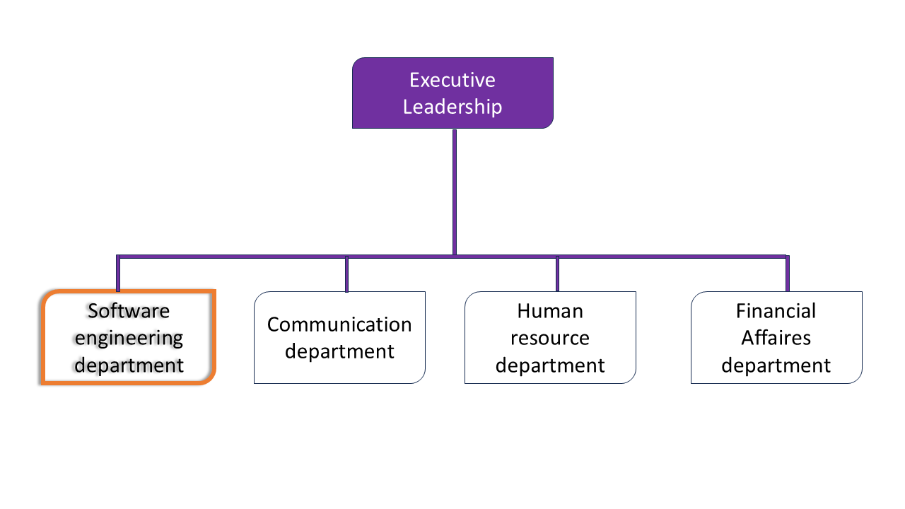

Figure 1: Functional organisation of Shaderl

## GEOGRAPHICAL LOCATION

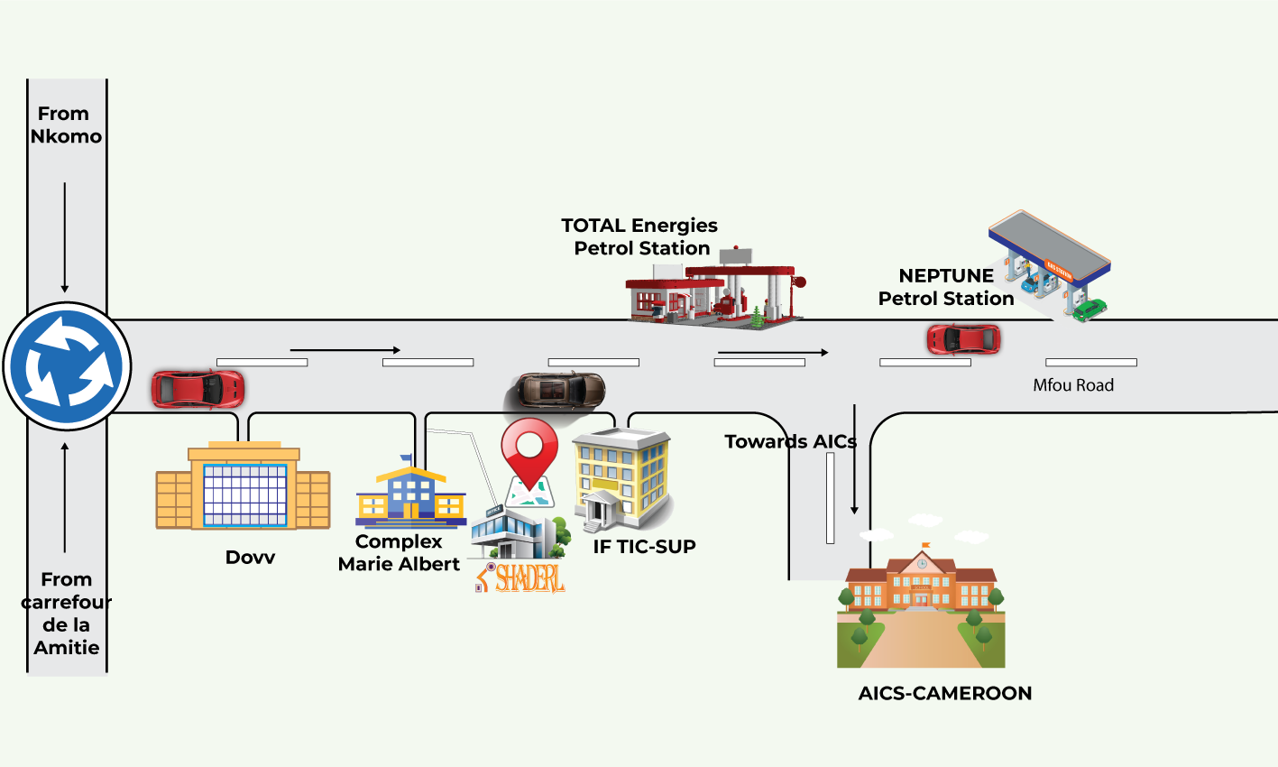

Figure 2 Geographical location of Shaderl

## BRIEF PRESENTATION OF THE PROJECT THEME

In Cameroon, students often struggle with ideational mathematical concepts like geometric analysis and vector spaces. To address this, our project focuses on DEVELOPMENT OF AN EDUCATIONAL 3D VISUALIZATION TOOL FOR GEOMETRICAL ANALYSIS that helps students visualize and explore these ideas dynamically. By bridging theory and practical understanding, the application aims to make mathematics more accessible and engaging for learners, fostering better comprehension and academic success.

## CONCLUSION

The insertion phase at SHADERL provided valuable insights into its operations and culture, equipping us to contribute effectively to the 3D visualization application and support its mission to advance mathematics education.

# PART 2: TECHNICAL PHASE

Preamble

This phase focuses on the structured development of the project, covering everything from initial analysis to final testing. It revolves around six key files that offer a comprehensive overview of the project's purpose, architecture, and anticipated performance. These documents serve as a guide through the presentation of the theme, the detailed analysis of its components, and the assessment of the solution's effectiveness—all of which are outlined below.

Content

INTRODUCTION

FILE 1: STUDY OF THE EXISTING SYSTEM

FILE 2: SPECIFICATION BOOK

FILE 3: THE ANALYSIS PHASE

FILE 4: THE CONCEPTION PHASE

FILE 5: THE REALIZATION PHASE

FILE 6: FUNCTIONALITY TEST

FILE 7: USER GUIDE

CONCLUSION

## INTRODUCTION

This section emphasizes the depth and rigor of the investigation carried out, highlighting the essential data gathered from the existing system to inform and guide the development of the application. It presents an overview of the current system, followed by a thorough analysis of the proposed solution and its implementation. The section concludes with a demonstration of the application and a summarizing conclusion that reflects on its performance and alignment with project goals.

# FILE 1: STUDY OF THE EXISTING SYSTEM

Preamble

Introducing the existing system forms a foundational aspect of this work, serving as the primary subject of the study. In the field of Information Technology, every project or development effort is typically initiated to enhance an existing system—improving its functionality, accessibility, and overall usability for the intended users.

Content

INTRODUCTION

1. PRESENTATION OF THE PROJECT THEME
2. DESCRIPTION OF THE EXISTING
3. CRITICISM OF THE EXISTING SYSTEM
4. PROBLEMATIC
5. PROPOSED SOLUTION

CONCLUSION

## INTRODUCTION

This document presents a detailed study of the existing system selected for the project, supported by a contextual overview of the theme to clarify the reasons behind its adoption. It offers an in-depth examination of the system's benefits, functionality, practical usage, and existing flaws. Through critical analysis, it identifies problems within the current approach and proposes effective solutions. Positioned within the broader investigation of contemporary methods for teaching geometrical concepts, this study highlights the need for improvement and sets the stage for introducing an interactive 3D visualization application- with goal as illustrating how such tools can technically and pedagogically enhance mathematics education, improve comprehension, and increase student engagement.

## PRESENTATION OF THE PROJECT THEME

In today’s educational landscape, enabling students to grasp complex geometrical concepts effectively and intuitively remains a key challenge. To address this need, we have decided to **DEVELOPMENT OF AN EDUCATIONAL 3D VISUALIZATION TOOL FOR GEOMETRICAL ANALYSIS**. This application will empower learners to explore and interact with mathematical structures in a dynamic three-dimensional environment.

The application provides users with a visual interface to generate and manipulate 3D graphs, helping them to understand spatial transformations and relationships more clearly. In addition to visualization, it offers an interactive practice space where users can bridge theoretical knowledge with real-world applications through problem-solving projects.

To foster deeper understanding, the app includes a built-in AI assistant that responds to questions and offers real-time guidance throughout the learning journey. Users can also monitor their academic growth through progress tracking features that highlight mastery and areas needing improvement.

Furthermore, the platform incorporates a concept library that provides curated definitions, examples, and test exercises aimed at reinforcing key geometrical principles. This centralized resource supports independent exploration and prepares students for assessments through targeted practice.

By blending interactive technology with pedagogical precision, this application aims to elevate geometry education, improve student engagement, and foster lasting comprehension. The theme behind our initiative reflects the commitment to transforming mathematical learning through innovation and accessibility.

## DESCRIPTION OF THE EXISTING SYSTEM

To meaningfully impact mathematics education in Cameroon, it is essential to first understand how it is currently practiced. The contemporary methods employed in most classrooms reflect long-standing conventions shaped by limited infrastructure, curriculum rigidity, and resource constraints. While these methods represent efforts to maintain consistency across schools, they often fall short in fostering intuitive understanding and learner engagement. A closer look at these approaches reveals several key limitations that underscore the need for innovation.

### Existing method of Mathematics Instruction

1. Contemporary Classroom Delivery

Mathematics instruction primarily relies on lectures and printed materials, with diagrams often presented in 2D formats. These resources establish foundational understanding and offer students structured approaches to problem-solving.

* **Visual Scope**: While effective for core content delivery, visual resources are typically static, which may limit the depth of spatial exploration for certain mathematical topics.
* **Mental Visualization**: Learners often interpret concepts through mental imagery, a process that varies by individual and may affect comprehension.

1. Theory-Centric Curriculum.

Curricula emphasize the development of theoretical reasoning and analytical skills. This provides students with a solid foundation for logical thinking and academic progression.

* **Real-Life Integration**: Practical applications may be introduced selectively, depending on classroom time and available teaching tools.
* **Instructional Tools**: Educators navigate constraints in time and infrastructure, balancing theory with interactive experiences when possible

1. Student Accessibility and Support Challenges

Students engage primarily with in-class resources, which vary by school setting and region. Supplementary tools are sometimes less readily available for self-guided learning.

* **Monitoring Practices**: Formal systems for tracking individual progress may be limited, particularly outside exam contexts.
* **Skill Development**: Opportunities for self-paced practice and exploratory learning depend on access to tailored resources beyond the standard curriculum.

### Performance and Survey Statistics

Statistical performance indicators over the past two academic years further illustrate these limitations, revealing patterns of disengagement and learning gaps across core geometry-related domains.

## CRITICISM OF THE EXISTING SYSTEM

Considering the statistics given we observe that the current system in place has several limitations that could be remedied using various solutions as illustrated in the table below

Table 1 Limitations of the Existing System

|  |  |  |
| --- | --- | --- |
| LIMITATIONS | CONSEQUENCES | SOLUTION |
| ****Heavy reliance on imagination:**** Students must mentally interpret complex geometrical structures without support | Confusion, fragmented understanding, and discouragement among students | Providing spatial exploration Environment that allow learners to engage with geometry from multiple perspectives and build understanding through interaction |
| ****Lack of initial visual support:**** Courses and materials rarely provide foundational visuals beyond basic 2D | Increased difficulty in interpreting and internalizing geometric structures | Enabling representations that move beyond flat depictions and offer dynamic visibility of mathematical relationships |
| ****Limited practical application;**** Concepts taught in isolation, rarely connected to real-world use | Learners struggle to find relevance, leading to disengagement and reduced retention | Designing a dedicated practice space where users can apply learned theory through contextualized tasks and guided exploration |
| ****Low student engagement**** Monotony in delivery methods hinders learning momentum | Passive learning habits and diminished curiosity in students | Reinventing interaction through a visually dynamic and interactive interface designed to boost curiosity and keep learners actively participating |
| ****Minimal student follow-up;**** Little to no tracking of individual progress or targeted intervention | Missed learning opportunities and stagnant development, hindering effective learning | Integrated dashboards, quizzes, and feedback loops to help users monitor learning, set goals, and receive intelligent guidance |
| ****Accessibility limitations;**** Resource constraints prevent students from exploring helpful tools | Unequal opportunities to deepen understanding and improve skills | Providing a centralized, user-friendly tool offering access to supportive content, explanations, and interactive learning at any time |

These challenges highlight the need for innovative approaches that connect theory with interactive learning. Addressing these gaps requires modern tools that make mathematics more intuitive and engaging—allowing students to experience concepts rather than just imagine them.

## PROBLEMATIC

In light of these persistent challenges in contemporary mathematics instruction, the central question becomes: **how can we effectively bridge the gap between conceptual knowledge and practical application to ensure students not only comprehend but actively engage with geometrical concepts?**

## PROPOSED SOLUTION

Here are the proposed solutions of our project to address the limitations of the existing system:

* Interactive 3D Visualization: Introduce dynamic 3D representations of abstract mathematical concepts, such as geometric transformations and vector spaces, to bridge the gap between theory and practical understanding.
* Engagement: Utilize interactive tools and user-friendly interfaces to make learning mathematics more stimulating and accessible for students.
* Simplified Comprehension: Provide students with visual aids that break down complex mathematical ideas into manageable and intuitive components.
* Practical Application: Offer features that allow students to experiment with mathematical concepts in real-time, fostering a deeper connection between theoretical knowledge and practical use.

These solutions aim to revolutionize mathematics education in Cameroon by addressing the shortcomings of traditional teaching methods and empowering learners with innovative tools.

## CONCLUSION

# FILE 2: THE SPECIFICATION BOOK

Preamble

The specification book outlines the essential directives for the development and delivery of the proposed software solution. It establishes a structured framework of steps and procedures that guide the understanding, definition, and realization of the project. This document serves as a reference point for aligning the development process with the client’s expectations, ensuring that all functional and technical requirements are clearly articulated and addressed.

Content

INTRODUCTION

1. CONTEXT AND JUSTIFICATION
2. OBJECTIVES OF THE PROJECT
3. EXPRESSION OF USER NEEDS
4. PROJECT PLANNING
5. ESTIMATED COST OF THE PROJECT
6. PROJECT CONSTRAINTS
7. DELIVERABLES

CONCLUSION

## INTRODUCTION

To ensure the successful realization of this educational application, clear and structured directives are essential. The specification book serves this purpose by defining the expectations of the client and the standards guiding the project’s development. It establishes a formal agreement between stakeholders and outlines the objectives, functional requirements, and scope of the system to be delivered. Within the context of an interactive 3D visualization tool for mathematics education, this document details the rationale behind the project, the specific educational needs it seeks to address, the development plan, and anticipated deliverables.

## CONTEXT AND JUSTIFICATION

### Context

As educational demands continue to grow, the need for effective mathematics instruction becomes increasingly critical. In Cameroon, students and educators often face significant challenges in accessing and engaging with mathematical concepts—particularly in areas such as geometric transformations and vector spaces. Many learners must rely solely on lectures and textbooks, which frequently lack visual depth and practical interactivity. This approach can be time-consuming and cognitively taxing, leading to delays in comprehension and diminished interest in mathematical learning.

Additionally, the heavy dependence on static, text-based resources introduce risks: learners often struggle to retain and apply complex ideas when they are presented without relatable context or visualization. Students may find themselves unable to interpret or recall key relationships between concepts, resulting in learning gaps and academic underperformance. Furthermore, the absence of structured, student-centred tools means that essential mathematical knowledge is not delivered in ways that support engagement, exploration, and long-term retention—ultimately compromising the quality of mathematics education.

### Justification

Mathematics education plays a vital role in shaping analytical thinking and academic success. In Cameroon, many students face persistent barriers to understanding key mathematical concepts, especially in areas such as geometric transformations and vector spaces. These challenges are linked to limited visual support, theory-heavy instruction, and a lack of tailored learning tools.

To address these shortcomings, we propose the conception and development of an interactive 3D visualization application. This solution will offer students dynamic learning tools to explore and interpret mathematical ideas more intuitively. By introducing responsive visual environments and guided interactions, the application will strengthen comprehension, increase student engagement, and support improved academic performance. It is designed to respond to the specific needs of learners in resource-constrained educational settings, contributing to a more inclusive and effective mathematics learning experience

## OBJECTIVES OF THE PROJECT

### General Objective

The primary objective of this project is to enhance students’ engagement and understanding of geometry by creating a digital learning space, using techniques that support independent learning, spark interest, and deepen understanding beyond conventional methods.

### Specific Objectives

The specific objectives of this project are to design and implement core features that support effective geometry learning through an interactive digital environment. These include:

* Graph Visualization**:** Enable users to enter mathematical functions and view corresponding 3D outputs, including tools for graph manipulation and dynamic interaction.
* Transformation Application**:** Provide guided modules for exploring geometric transformations, with step-by-step explanations and visualization of resultant forms.
* User Profile Management**:** Enable personalized user experiences, including login, logout, account creation, and secure data handling.
* Interactive Testing**:** Include a dedicated area for multiple-choice questions to reinforce understanding and evaluate knowledge. Present open-ended challenges focused on deeper concept mastery and problem-solving beyond standard formats.
* Practice Environment**:** Simulate real-life applications of mathematical concepts, allowing users to work through examples, explanations, and challenge scenarios.
* Concept Library**:** Offer access to well-organized reference materials covering key mathematical concepts and definitions relevant to geometry and beyond.
* AI Chat Assistance**:** Integrate an intelligent chat system to offer contextual guidance, answer questions, and support learning pathways in real time.
* Progress Dashboard**:** Visualize learning progress through analytics and feedback, allowing students to track achievements and growth over time.

## EXPRESSION OF USER NEED

### Functional Needs

• Input equations and visualize their results dynamically in 3D. • Manipulate 3D models through zooming, rotating, and transforming. • Provide guided exercises and examples for exploring mathematical concepts. • Offer interactive tools for solving and analyzing equations.

### Non-functional Needs

**Responsiveness** Ensure Smooth performance across devices—PC, tablet, mobile—with snappy transitions and minimal lag.

**Accessibility** Clear visuals, keyboard navigation, screen-reader compatibility, and multi-language support.

**Scalability** Capable of supporting large numbers of users without performance drops.

**Security & Privacy** Data protection for user accounts and quiz results, following GDPR-like standards.

**Usability** • Maintain a clean, intuitive user interface accessible to students of varied digital literacy levels. Provide helpful tooltips, guided navigation, and an AI assistant for smooth interaction.

Intuitive design with consistent UI patterns and visual cues for navigation.

**Maintainability** Modular codebase to allow updates, fixes, and feature additions with minimal disruption.

## PROJECT PLANNING

The planning of a project is an activity that consists of determining the tasks performed and putting them in order by presenting them in intervals of time. We will present the Gantt diagram of our project and a tabulated form.

Table 2Project Planning

|  |  |  |  |  |
| --- | --- | --- | --- | --- |
| NAME | OBJECTIVE | OUTCOME | ACTORS | DURATI  ON |
| INSERTION | Integration of internship environment | Insertion Report phase | -Mrs Kom  -Mr Epoupa  -Mr Asane | 14 DAYS |
| EXISTING  SYSTEM | Exploring the Existing system: Functioning, limitations and solution Up bringing | Study of the Existing System File | Mrs Kom | 3 Days |
| SPECIFICATION BOOK | Specification of user needs and giving the objectives and constraints of our project. | The Specification Book | - Mrs Kom  -Mr Ndifor  Mr Epoupa | 14 Days |
| ANALYSIS | Presentation of behavioural diagrams and comparative study of UML and MERISE. | The Analysis File | -Mrs Kom  - Mr Epoupa  -Mr Ndifor | 18 Days |
| CONCEPTION | Preliminary and detailed conception | The Conception File | -Mrs Kom | 13 Days |
| REALISATION |  | The Realisation File | Mrs Kom | 14 Days |
| DEPLOYMENT | Development and some  diagrams | The Deployment File | - Mrs Kom | 6 Days |
| TESTING | Unitary Testing | Functionality Test File | - Mrs Kom | 5 Days |
| USER GUIDE AND  INSTALLATION | Provide Detailed Usage Steps for The Application | Installation and user Guide | - Mrs Kom | 5 Days |

## ESTIMATED COST OF THE PROJECT

### Hardware Resources

It will be wise for the development of our project to have the material resources below:

Table 3 Hardware Resource Estimation-(source mercurial 2025)

|  |  |  |  |  |  |  |
| --- | --- | --- | --- | --- | --- | --- |
| NO | NAME | REFERENCE NO | USAGE | QTY | Unit Price | COST  (FCFA) |
| 1 | Laptop DELL  LATITUDE  5420-N 14" CI5-  1135G7/ 8GB /  256GB SSD/  LINUX | 35-013-200255 | Work space for users | 1 | 1001000 | 1001000 |
| 2 | USB Key (Flash  Drive) 4GB | 01-003-200017 | For storage | 1 | 6900 | 6900 |
| 3 | Realm of Paper | 31- 004-140017 | Print hard copy | 1 | 14 375 | 14 375 |
| 5 | HP laserjet  Printer | 37-011-140018 | Print hard copy reports | 1 | 105 800 | 105 800 |
| 6 | HP Wired Mouse | 01-007-200225 | To better work on laptop | 1 | 5900 | 5900 |
| 7 | USB Cable 2.0 | 01.007.200185 | transport documents into phones | 1 | 2300 | 2300 |
|  | **TOTAL** |  |  |  | | 1 136 275Frs |

### Software Resources

Table 4 Software Resources Estimation -( source: Mercurial 2025)

|  |  |  |  |
| --- | --- | --- | --- |
| SOFTWARE | DESCRIPTION | QTY | PRICE |
| Visual Studio Code | Text editor used to write code | 1 | FREEWARE |
| Android Studio | IDE for Android app development | 1 | FREEWARE |
| WPS | Office suite for word processing and spreadsheet tasks | 1 | FREEMIUM |
| Gantt Project | Software used to manage project time and planning | 1 | FREEMIUM |
| Visual-paradigm  Modeler version | Software used for diagram modeling | 1 | 20 000 |
| Google Chrome | Web browsers used to launch and test applications | 1 | FREEWARE |
| Firebase | Backend service for app development | 1 | Open source |
| TOTAL |  |  | 20 000 FCFA |

### Human Resources

For a good realization and setting up of our project, it is wise to make an estimate in terms of manpower.

Table 5 Human Resources Estimation- ( Source: mercurial 2025)

|  |  |  |  |  |
| --- | --- | --- | --- | --- |
| ACTORS | NUMBER | DURATION  (DAYS) | PAYMENT PER  MONTH | TOTAL AMOUNT |
| Project  Manager | 1 | 90 | 300 000 FCFA | 900 000 FCFA |
| Analyst | 2 | 60 | 250 000 FCFA | 1000 000 FCFA |
| Designer | 1 | 30 | 100 000 FCFA | 100 000 FCFA |
| Database  Manager | 1 | 45 | 300 000 FCFA | 450 000 FCFA |
| Developers | 1 | 90 | 250 000 FCFA | 1 500 000 FCFA |
| TOTAL | 7 |  | 1 200 000 FCFA | 3 950 000 FCFA |

### Global Estimation of the Project

*Table 10: Global cost of the project*

Table 6 Global cost Estimation

|  |  |
| --- | --- |
| TYPES | PRICE |
| Hardware Resources | 1 136 275 FCFA |
| Software Resources | 20 000 FCFA |
| Human Resources | 3 950 000 FCFA |
| Total | 5 106 275 FCFA |
| Unexpected charges (10%) | 510 627 FCFA |
| TOTAL | 5 616 902 FCFA |

After the evaluation of the budget of conception, realization, transfer of competence, software and material usage, we can estimate the total cost of the project at **5 616 902 FCFA**

## PROJECT CONSTRAINTS

* Quality Constraints: The application must deliver precise and reliable 3D visualizations of key mathematical concepts—such as geometric transformations and vector spaces—in a manner that supports clarity, usability, and pedagogical relevance for students.
* Time Constraints: The development lifecycle—including design, implementation, testing, and deployment—must be fully executed within the internship duration of 3 months. Milestones should be clearly defined to ensure steady progress, with contingency buffers for bug fixes, feedback integration, and final optimization.
* Cost Constraints: The project must be developed and deployed within the limits of available financial and technical resources. This includes strategic selection of tools for 3D visualization, AI integration, and database management, as well as cost-effective planning for frontend/backend development and testing infrastructure.

## DELIVRABLES

The final output is a fully functional and interactive 3D visualization application designed to enhance mathematics education. This tool will support both students and educators by enabling clear, engaging representation of mathematical concepts.

The deliverable package includes:

* **Internship Report**: A comprehensive documentation of the development process, design decisions, testing strategies, and final reflections.
* **User Guide**: Embedded within the report or as a standalone document, explaining how to navigate and utilize the application’s features.
* **Presentation Slides**: A visually compelling PowerPoint summarizing the problem statement, solution, development process, and impact.
* **Functional Application**: A well-tested, intuitive, and visually engaging application ready for deployment and use in educational settings.

## CONCLUSION

This specification document consolidates the detailed requirements, objectives, constraints, and deliverables essential to the successful development of the interactive 3D visualization application. By responding to the limitations of conventional mathematics instruction, the project introduces a dynamic, visually driven educational tool designed to demystify abstract mathematical concepts and enhance learner engagement. Through clearly defined features, timelines, and resource boundaries, this specification ensures a coherent and methodical development process, culminating in a robust and user-friendly solution tailored for students and educators.

# file 3: the ANalysis File

Preamble

This section of the report will cover details of how we were welcomed in the host company, presentation, organization and brief introduction to our project.

Content

INTRODUCTION

1. METHODOLOGY
2. COMPARATIVE STUDY OF UML AND MERISE
3. COMPARATIVE STUDY OF UNIFIED PROCESSES
4. CHOICE OF THE ANALYSIS METHOD
5. MODELLING THE PROPOSED SOLUTION

CONCLUSION

## INTRODUCTION

System development can be thought of as having two major components: System analysis and system design which both help in understanding the details of the existing system or the system to be designed. The analysis and design of information systems has most of the time vocation to allow the creation of databases, which must represent as closely as possible the reality of the field studied thus requiring the use of a design method. This is why our choice will be directed on the UML method as it offers much to developers seeking a user-centered approach and / or a wide scope in design. This part of the report consists of the comparative study of UML and MERISE, unified processes and finally the various diagrams that meet the functional need requirements.

## METHODOLOGY

### COMPARATIVE STUDY OF UML AND MERISE

#### MERISE

MERISE stands for “Méthode d’Etude et de Réalisation Informatique pour des Systèmes d’Entreprise”. Although it is prescriptive to some extent, MERISE permits the participation of end users and senior management as well as data processing professionals in its decision cycle. MERISE is a method for designing, developing and carrying out IT projects. The goal of this method is to achieve the design of an information system. The MERISE method is based on the separation of data and processing to be carried out in several conceptual and physical models. The essentials of the approach lie in its three cycles: the decision cycle, the life cycle and the abstraction cycle, which cover data and process elements equally. The separation of data and processing ensures longevity in model. Indeed, the arrangement of data does not have to be often overhauled, while treatments are more frequently.

#### UML

UML (Unified Modelling Language) is a standard notation for the modelling of real world objects as a first step in developing an object-oriented design methodology. Its notation is derived from three object-oriented design and analysis methodologies: Grady Booch's methodology for describing a set of objects and their relationships, James Rumbaugh's Object-Modelling Technique (OMT), Ivar Jacobson's approach which includes a use case methodology. Other ideas also contributed to UML, which was the result of a work effort by Booch, Rumbaugh, Jacobson, and others to combine their ideas, working under the sponsorship of Rational Software. UML captures information about the static and dynamic view of a system. UML 2.5 comprises of 14 diagrams which represent the different views of a system. The 14 diagrams can be subdivided into two, Static or structural and Dynamic diagrams. These diagrams include

##### STATIC OR STRUCTURAL DIAGRAMS

* Class diagram;
* Object diagram;
* Component diagram;
* Deployment diagram;
* Composite Structure diagram;
* Package diagram;
* Profile diagram;

##### BEHAVIOURAL DIAGRAMS

* Use case diagram;
* Activity diagram;
* State machine diagram;
* Sequence diagram;
* Communication diagram;
* Global interaction/ interaction Overview diagram;
* Timing diagram;

On very important notice is that UML is not a method but a modelling language. As such to give it an approach we need to associate UML to a Unified Process (UP) in other to give our conception a methodology to follow. There exist several Unified Processes, but our modelling approach will be the 2TUP (Two-track unified process) which we will use in the course of our project

### COMPARATIVE STUDY OF UNIFIED PROCESSES

### Unified Process

A Unified Process is a process of development of software constructed on UML; it is iterative, incremental, centered on architecture, driven by use cases and requirements.

Iteration is distinct sequence of activities with a basic plan and evaluation criterion that produces an internal or external output. Either the content of an iteration is improved, or the evolution of the system is evaluated by users.

An increment is the difference between two released products at the end of two iterations. Each iteration that the group is capable of integrating the technical environment in order to develop a final product and give users the possibility of having tangible results.

Centred on architecture the different models derived during the establishment of system must be reliable and coherent.

Driven by use case and requirements enables the clear definition of a users’ needs and priorities respectively thereby minimizing the risk of project

### The Two Track Unified Process(2 TUP)

2TUP is a unified process which is built on UML and has as objective to bring solution to constraints of functional and technical changes imposed on information systems by strengthening controls on development capacities. It proposes a Y-sharped development life cycle that separates the functional aspect from the technical aspects, and the merging of these two forms the implementation aspect. 2TUP distinguishes therefore two branches: the functional and technical branches, the combination of the result of these two branches forms the third: the realization branch – where we realize our system. The diagram below illustrates the branches of the 2TUP.

diagram

#### The Left Branch (Functional Branch)

It captures the functional needs of a system. This ensures the production of software that meets the needs/requirements of the user. The analysis here consists of studying precisely the functional specification in order to obtain an idea of what the system is going to realize, and its result does not depend on any technology.

#### The Right Branch (Technical Branch)

The technical branch enumerates the technical needs and proposes a generic design validated by a prototype. The technical needs include constraints and choices related to the conception of the system, the tools and equipment as well as the integration constraint with the existing system condition.

#### The Middle Branch (Realization or Implementation Branch)

In this branch, we study the preliminary conception, detailed conception, and documentation of the system. The realization branch supports the following:

Preliminary conception: This is the most sensitive step of 2TUP as it is the confluence of the functional and technical branch. It is completed when the deployment model, the operating model, the logical model, interphases and the software configuration model are defined. We have the following diagrams:

* Component diagram;
* Deployment diagram;
* Package diagram,
* Composite Structure diagram;

Detailed conception: This is the detailed design of each feature of the system. We have the following diagrams:

* Class diagram
* Object diagram;
* Sequence diagram;
* Timing diagram;

Coding and testing: This is the phase where we program the designed features and test the coded features.

The recipe: Also known as the deliverables is the validation phase of the functions of the developed system.

# file 4: THE CONCEPTION FILE

Preamble

This section of the report will cover details of how we were welcomed in the host company, presentation, organization and brief introduction to our project.

Content

INTRODUCTION

1. THE ARCHITECTURE OF THE APPLICATION
2. RELATED UML DIAGRAMS
3. CLASS DIAGRAM
4. STATE MACHINE DIAGRAM
5. PACKAGE DIAGRAM

CONCLUSION

## INTRODUCTION

The conceptual phase will describe in detail the necessary specifications, features and

operations that will satisfy the functioning requirements of the proposed system as

modelled in the analysis phase. This phase is meant to identify and consider essential

components (hardware and software), structure (network capabilities), processes and

procedures for the system to accomplish it objectives. We will look at some diagrams

such as the class diagram, state machine diagram and package diagram.

## THE ARCHITECTURE OF THE APPLICATION

Every application requires architecture or a particular structure. It is that structure that describes the interaction between components of the software. At the level of the architecture, we have the:

* PHYSICAL ARCHITECTURE
* LOGICAL ARCHITECTURE

### PHYSICAL ARCHITECTURE

The design of the DBMS depends on its architecture. An n-tier architecture partitions on the whole system into related but separated n modules, which can be independently modified, altered, changed or replace. Within the scope of our project, we made use of a 3-tier architecture which is popularly known as the three layers architecture. This architecture separates its tiers from each other based on the complexity of the user and how they manipulated data in the database. Each layer has a well-defined communication interface and the evolution of a layer is independent of the other.

#### THE THREE LEVELS

##### The User(Presentation) Tier

At this layer, multiple views of database can be provided by the application. All views are generated by applications that reside in the application tier. End-users operate on this tier and they know nothing about the existence of the database beyond this layer. In other words, it acts as an assembly of services and applications offered by the lower layer. This layer relays the queries of the users and in return, the result from the database.

##### The Application(Logical or Middle) Tier

At this tier resides the application server and the program that access the database. For a user, this application tier presents an abstract view of the database. End users are unaware of any existence of the database beyond the applications. At the other end, the database tier is not aware of any other user beyond the application tier. Hence, the application layer sits in the middle and acts as a mediator between the end-user and the database.

It acts as the functional part of the application which implements the logic and which describes the operations that the application operates on the data according to the user request, carried out through the application layer. The various management rules and system controls are incorporated at this level. For appropriate functionality, it interacts with the data base layer by sending and receiving queries for the application.

##### The Database(data) Tier:

At this tier, the database resides along with its query processing languages. We also have the relations that defines the data and their constraints at this level. It manages the access to the data of the system.

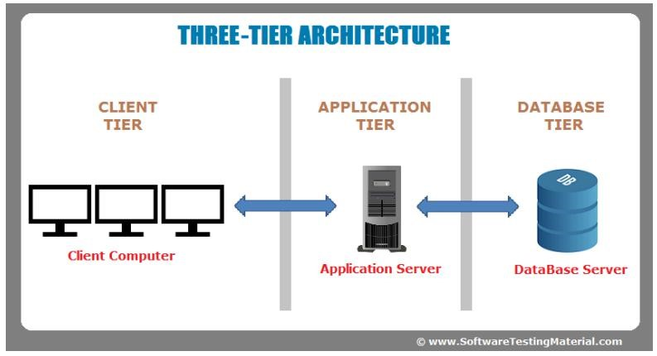

Figure 3 Physical Architecture illustration showing the 3 levels of this architecture

### LOGICAL ARCHITECTURE

Model view controller or MVC is popularly called, is a software design pattern for developing we application. A Model View Controller is made up of the following three parts:

* **Model:** The lowest level of the pattern which is responsible for maintaining data.
* **View:** This is responsible for displaying all or a portion of the data to the user.
* **Controller:** Software code that controls the interactions between the model and the view.

MVC is popular as it isolates the application logic from the user interface layer and supports separation of concerns. Here the controller conceives all requests for the application and then works with the model to prepare any data needed for the view. The view then uses the data prepared by the controller to generate a final presentable response. The MVC abstraction can be graphically represented as follows.

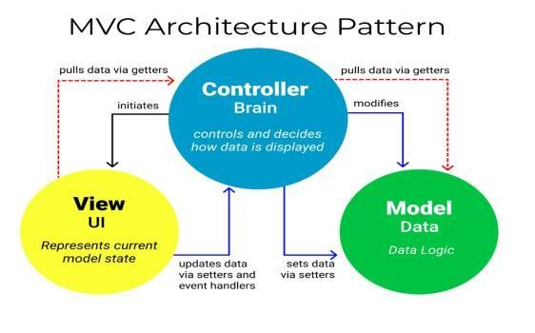

Figure 4:The MVC architecture (Source: https://www.freecodecamp.org/news/themodel-view-controller-pattern-mvc architecture-and-frameworks-explained/)

## RELATED UML DIAGRAMS

### CLASS DIAGRAM

#### Definition

A class diagram is a static diagram. It represents the static view of an application.class diagram is not only used for visualizing, describing and documenting different aspect of the system but also for constructing executable code of the software application. Class diagram describes the attribute and operation of a class and constraints imposed on the system. Its purpose is to model the static view of an application.

#### Formalism

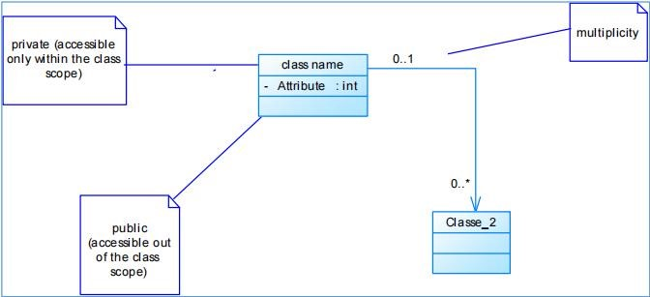

Figure 5 Class Diagram Formalism

#### Diagram Elements

Table 7: Class Diagram Elements

|  |  |  |
| --- | --- | --- |
| ELEMENTS | REPRESENTATION | DESCRIPTION |
| Class |  | A class is an element that defines the attributes and behaviours that an object can generate |
| Composition |  | If a parent of a composite is deleted, usually, all its parts are deleted with it |
| Aggregation |  | If the parent of the aggregate is deleted, usually the children are not deleted. |
| Generalization |  | A generalization is used to indicate inheritance. It shows a parent class generalizing a child class. |
| Association |  | It is the general relationship type between elements. This connector may include named roles at each end, cardinalities, direction and attributes. |

#### System Diagram

### STATE MACHINE DIAGRAMS

#### Definition

A state machine diagram describes the behaviour of a single object in response to a series of events in a system. Also known as the state machine diagram, it models the dynamic flow of control from the state of a particular object within a system.

#### Formalism

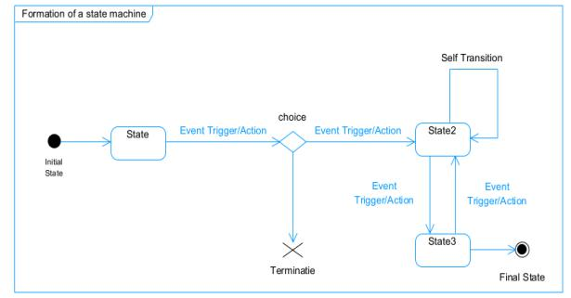

Figure 6: State machine diagram Formalism

#### Elements

Table 8: State machine Diagram Elements

|  |  |  |
| --- | --- | --- |
| ELEMENTS | REPRESENTATION | DESCRIPTION |
| State |  | Models a state during which a certain invariant condition holds. |
| Initial State |  | It represents a default vertex, that is, a source for a single transaction to the default or composite state. |
| Final State |  | A state specifying that the enclosing region is complete. |
| Transition |  | A direction relation between a source and a target vertex. |
| Choice pseudo state |  | A diamond symbol that indicates a dynamic condition with branched  potential results |

#### System Diagram

### PACKAGE DIAGRAM

#### Definition

This is a structural diagram used to show the organization and arrangement of various model elements in the form of packages. It allows the system to be broken down into more easily observable categories or parts called packages. A package diagram is the grouping of related UML elements such as classes, diagrams or even other packages.

#### Formalism

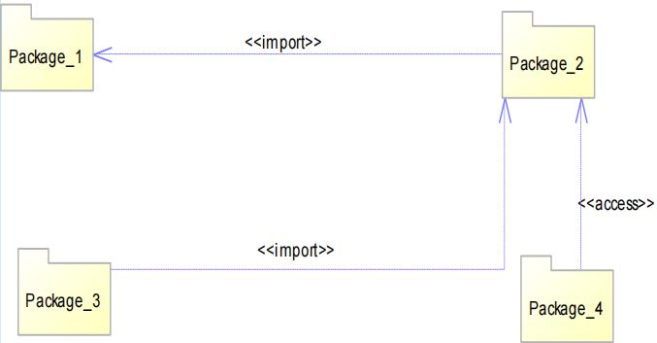

Figure 7: Package Diagram Formalism

#### Diagram Elements

Table 9: Package Diagram Elements

|  |  |  |
| --- | --- | --- |
| ELEMENTS | REPRESENTATION | DESCRIPTION |
| Package |  | A package is a name-space use to group related elements; it is a mechanism used to group elements into a better structure in a system. |
| Import Dependency |  | A relationship Indicate that, a functionality has been imported from one package to another. |
| Access Dependency |  | A relationship Indicates that one package requires assistance from the function of another package. |
| Merge Dependency |  | It is a relationship which shows that, the functionality of two packages are combines to  a single function |

# File 5: the Realisation file

Preamble

This section of the report will cover details of how we were welcomed in the host company, presentation, organization and brief introduction to our project.

Content

INTRODUCTION

1. DEPLOYMENT DIAGRAM
2. COMPONENT DIAGRAM

CONCLUSION

## INTRODUCTION

In this phase also known as the realization phase, we will present some diagrams related to the physical aspect of the system like libraries, documents, as well as the physical topology of the components of the system when the software is been deployed.

## DEPLOYMENT DIAGRAM

#### Definition

Deployment diagram is a structural diagram used to visualize the topology of the physical components of a system, where the software is deployed. They consist of nodes and their relationship. It is related to the component diagram because the components are deployed using the deployment diagram. A deployment diagram consists of nodes. Nodes are nothing but physical hardware used to deploy the application.

#### Formalism

Figure 8: Deployment Diagram Formalism

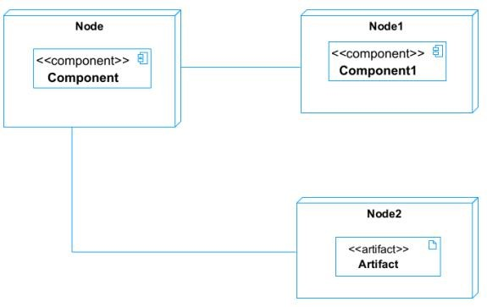

#### Diagram Elements

Table 10: Deployment diagram Elements

|  |  |  |
| --- | --- | --- |
| ELEMENTS | REPRESENTATION | DESCRIPTION |
| Node |  | It is a hardware used to deploy the application |
| Artifact |  |  |
| Component |  |  |
| Association |  |  |

#### System Diagram

### COMPONENT DIAGRAM

#### . Definition

Component diagrams are used to model the physical aspect of a system. Now the question is what are this physical aspect? They are elements such as Executables, libraries, files, document etc. which resides in a node. The component diagram does not describe the functionality of the system, but it describes the components used to make those functionalities.

#### Formalism

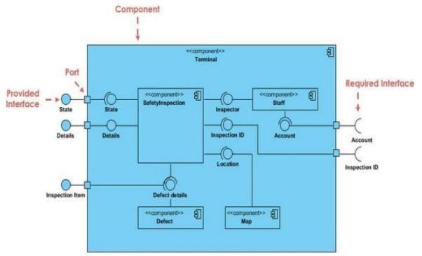

Figure 9: Component Diagram Formalism

#### Diagram Elements

Table 11: Component Diagram Elements

|  |  |  |
| --- | --- | --- |
| ELEMENTS | REPRESENTATION | DESCRIPTION |
| Component |  | A component is an abstract logical unit block of a system.it is represented as a rectangle with smaller rectangle in the upper right corner which saves as it icon for recognition. |
| Dependency |  | Dependency is a directed relationship which is used to show that some components are dependent on others for their correct functioning. |
| Interface |  | An interface (small circle or semicircle on a stick) describes a group of operations used (required) or created (provided) by components. A full circle represents an interface created or provided by the component. A semicircle represents s required interface, like a person’s input |
| Port |  | Ports represented using a square along the edge of the system or a component. A port is often used to help expose required and provided interfaces of a components |

#### System Diagrams

# FILE 6: FUNCTIONALITY TEST

Preamble

This section of the report will cover details of how we were welcomed in the host company, presentation, organization and brief introduction to our project.

Content

INTRODUCTION

1. APPLICATION FUNSTIONALITIES
2. TESTS SHOWCASES

CONCLUSION

## INTRODUCTION

## APPLICATION FUNCTIONALITIES

## TEST SHOWCASE

## CONCLUSION

# FILE 7: INSTALLATION AND USER GUIDE

Preamble

This section of the report will cover details of how we were welcomed in the host company, presentation, organization and brief introduction to our project.

Content

INTRODUCTION

1. APPLICATION INSTALLATION
2. SHOWCASES

CONCLUSIONS

## INTRODUCTION

## APPLICATION INSTALLATION

## SHOWCASES

## CONCLUSION

# GENERAL CONCLUSION

In conclusion, this project presents an innovative approach to mathematics education by integrating interactive 3D visualizations, concept explanations, and dynamic graph transformations. Designed as a downloadable, user-friendly tool, it provides students with a hands-on learning experience that enhances understanding and engagement. By combining mathematical modelling with clear explanations and integrated assessments, the system fosters deeper comprehension and retention. Moreover, its scalable architecture ensures adaptability, allowing for future advancements such as AI and extended functionalities. This project marks a significant step toward modernizing math education, offering students an accessible and immersive way to explore complex concepts

# BIBLIOGRAPHY

# WEBOGRAPHY

# ANNEXES

# TABLE OF CONTENTS